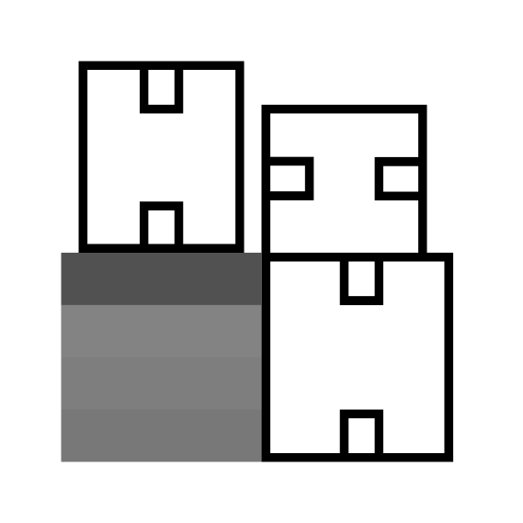**Docker Cheat-Sheet**

**Commands for Containers**

* Start and run a new container

docker run <image name>

* Reattach to a container

docker attach <container ID or name>

* Forcibly stop a container

docker stop <container ID or name>

* Restart a previously stopped container

docker start <container ID or name>

* Remove a container

docker rm <container ID or name>

* Run a command in an existing container

docker exec <container ID or name> <command>

* List running containers

docker ps

* List all containers (running and stopped)

Detaching from a container

Ctrl + P then Ctrl + Q

docker ps -a

* Get the logs of a container

docker logs <container ID or name>

* Get detailed information about a container

docker inspect <container ID or name>

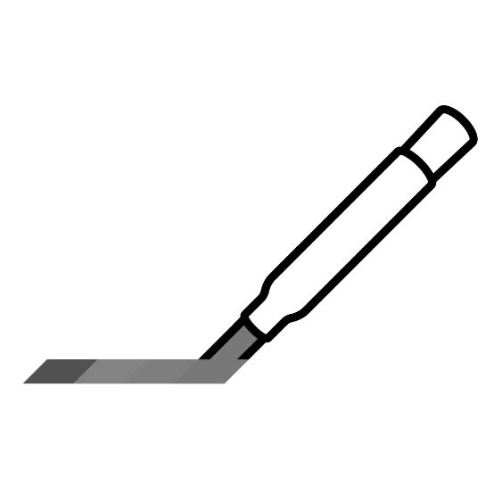

**Commands for Images**

* Download an image from a registry

docker pull <image name>

* Remove an image from the local disk

docker rmi <image ID>

* List all locally available images

docker images

* Commit all changes of a container to a new image

docker commit <container ID or name> <tag>

* View the history of an image

docker history <image ID or tag>

* Upload an image to a registry

docker push <image ID or name>

* Tag an image

docker tag <container ID or name> <tag>

* Build an image from a Dockerfile

docker build <path to build context>

**Tagging an image for pushing to a registry**

docker tag myimage myregistryhost/repository/myimage:release1.0

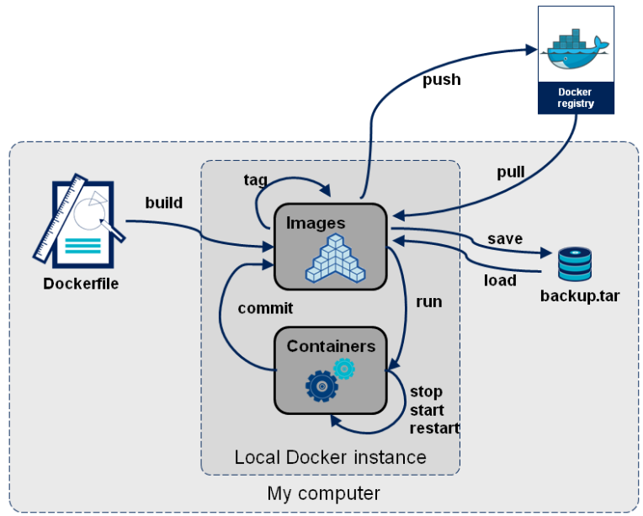

Docker Container Lifecycle